FIRST YEAR

|  |
| --- |
| **prophecy** |
| The Bible and the Future |

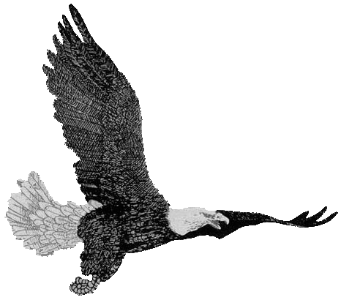WORKBOOK

**DELIVERANCE BIBLE INSTITUTE**

*Portland, Maine, USA*

|  |
| --- |
| Prophecy |
| The Bible and the Future |
|  |

Syllabus 1

Calendar 3

LESSON 1 4

# 

# Study Questions 1

1. What type of a book is the Bible?

The Bible is a prophetic book.

2. How much of the Bible is prophetic?

Two-thirds of Scripture is prophetic.

3. In what way is the Bible prophetic?

The Bible is prophetic in types, symbols and direct statement.

4. What does the Bible base its authenticity, authority and inspiration on?

The Bible bases these on prophecy.

5. What is prophecy?

The telling of history before it happens.

6. What is meant by prophecy being two-fold?

1. It is predictive—foresight; foretelling

2. It is descriptive—insight; forthtelling

7. Is prophecy reasoned discourse?

No, it is the utterance of the Holy Ghost.

8. Give verbatim II Peter 1:21.

2 Peter 1:21—For the prophecy came not in old time by the will of man: but holy men of God spake as they were moved by the Holy Ghost.

9. Why do we study prophecy?

1. That we may know God’s plan.

2. That we may understand the future.

3. That we may not be lead into error.

10. What is the proof of prophecy?

1. It must be beyond human reasoning or foresight.

2. It must have been made known prior to its fulfillment.

3. It must have a clear, detailed fulfillment.

11. To whom is prophecy written?

Prophecy is written to Jews, Gentiles and the Church.

12. Give verbatim I Cor. 10:32.

I Cor. 10:32—Even as I please all men in all things, not seeking mine own profit, but the profit of many, that they may be saved.

# Quiz 1

1. What type of a book is the Bible?

The Bible is a prophetic book.

2. How much of the Bible is prophetic?

Two-thirds of Scripture is prophetic.

3. In what way is the Bible prophetic?

The Bible is prophetic in types, symbols and direct statement.

4. What does the Bible base its authenticity, authority and inspiration on?

The Bible bases these on prophecy.

5. What is prophecy?

The telling of history before it happens.

6. What is meant by prophecy being two-fold?

1. It is predictive—foresight; foretelling

2. It is descriptive—insight; forthtelling

7. Is prophecy reasoned discourse?

No, it is the utterance of the Holy Ghost.

8. Why do we study prophecy?

1. That we may know God’s plan.

2. That we may understand the future.

3. That we may not be lead into error.

9. What is the proof of prophecy?

1. It must be beyond human reasoning or foresight.

2. It must have been made known prior to its fulfillment.

3. It must have a clear, detailed fulfillment.

10. Give verbatim I Cor. 10:32.

I Cor. 10:32—Even as I please all men in all things, not seeking mine own profit, but the profit of many, that they may be saved.